Manil S Malla

wcrecent@gmail.com

Proving the validity of Predicate Logic using VIP32

AI Lab 6

Predicate Logic

**Translate the following arguments into prolog and prove the validity of the following:-**

1. All greedy leaders are autocrats. Autocrats are evil. Prashant is a greedy leader. Ram is an honest leader. Therefore Prashant is evil.

* Code

PREDICATES

greedyleader(symbol)

autocrat(symbol)

evil(symbol)

honestleader(symbol)

CLAUSES

greedyleader("Prashant").

honestleader("Ram").

autocrat(X):-greedyleader(X).

evil(Y):-autocrat(Y) .

GOAL

evil("Prashant").

* Output

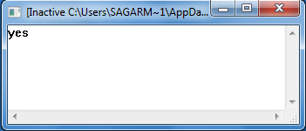

1. Jane is Paul’s mother. Jane is Mary’s mother. Any two people sharing the same mother are siblings. Therefore Paul and Mary are siblings.

* Code

PREDICATES

mother(symbol,symbol)

sibling(symbol,symbol)

CLAUSES

mother("Jane","Mary").

mother("Jane","Paul").

sibling(X,Y):- mother(Z,X),

mother(Z,Y).

GOAL

sibling("Mary","Paul").

* Output

